Server Memory Installation Guide
- Turn off your computer and disconnect all cables and power cord from your computer.
- Please note: it is important that you discharge any static electricity which may have built up in your body or clothing before handling the memory modules to avoid damage. This can be done by:
  - Touching an unpainted, grounded metal surface first.
  - Alternatively, you can wear an Electro Static Discharge (ESD) protective wrist strap.
  - Holding the memory module at the edges and avoiding contact with the memory chips.
- Locate the memory sockets on your computer’s mainboard. You may wish to refer to your computer’s user guide for help locating them. They should be the longest black slots on the motherboard.
- Remove any existing memory modules, if necessary. If all memory sockets are currently populated, you might want to replace the lower capacity memory modules with those of a higher capacity.
- For DIMMs, remove the existing memory modules by unlocking retaining clips/tabs away from each module, then pulling it out of the socket carefully.
- Some computers require a specific sequence of memory sockets to be populated, based on the memory modules’ capacity. Refer to your computer user guide and determine the socket sequence specified for the memory upgrades, if any.
- Line up the memory module with the bank and line up the notches with the corresponding features on the banks.
- Push the memory module straight down. The tabs should pop back if you install the ram properly.
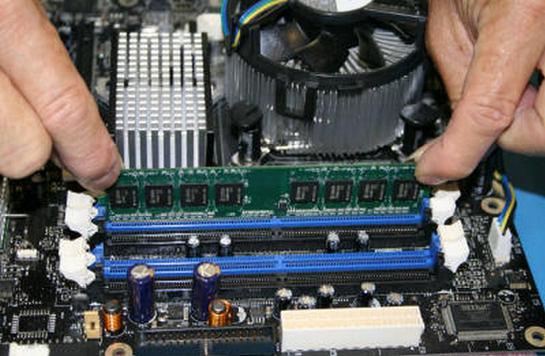
- Reattach your computer cover, reconnect the power cord and boot up the system
- Most computers will automatically recognize the upgraded memory on the next boot, while some may require you to configure the new memory. In this instance, please check your computer and operating system user guides.
- The installation of memory modules is complete.
- For more support details, warranty and return policy, do visit the other sections on www.strontium.biz

